**Implementing Attribute View with Inner Join**

Attribute view:

* Attribute views are dimensions used to join master data.
* Master data is a data which is not going to change frequently.

**Inner Join**:

* The inner join select the records that match in both the tables
* Inner join should be used if referential integrity is ensured.
* Inner Join is much faster that Outer Join thus is the preferred solution if possible from semantically perspective.
* Inner Joins can be used to join different master data tables to a joint dimension Analytical Views.
* Inner Joins can be used if referential integrity cannot be ensured

Right click on calculation view<click new

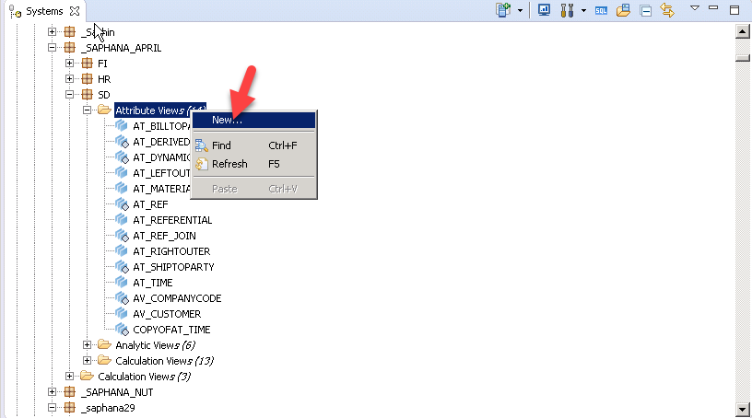

Provide name as AT_INNER_JOIN and click finish

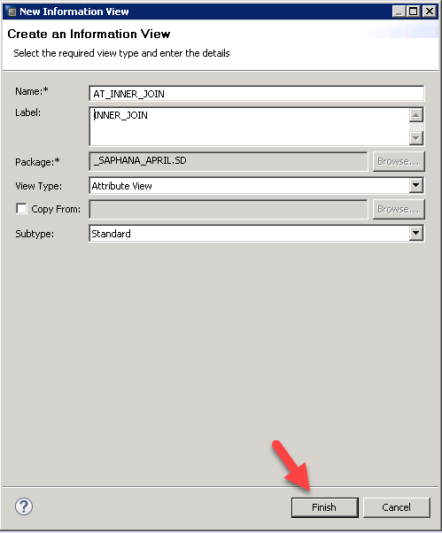

Click on data foundation + icon to add table

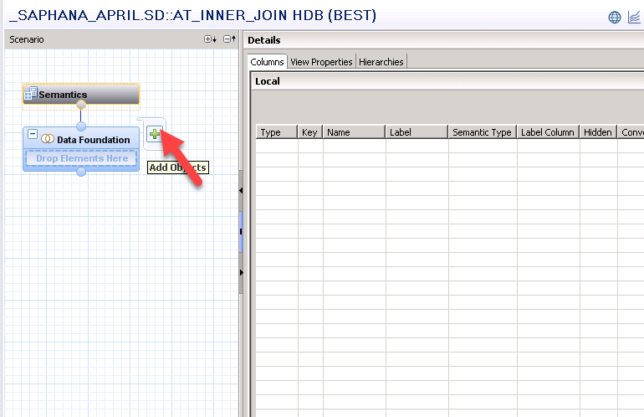

Select T001 table and click ok

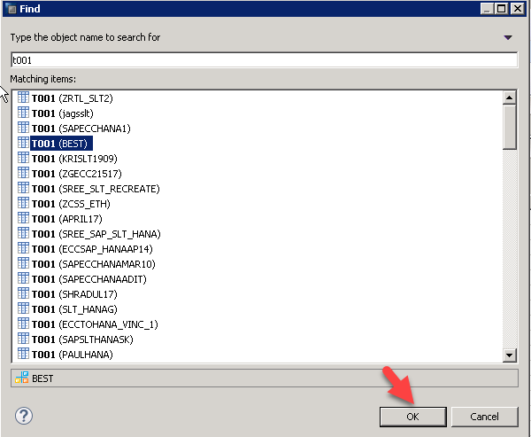

Again click on data foundation +icon to add TVKO table

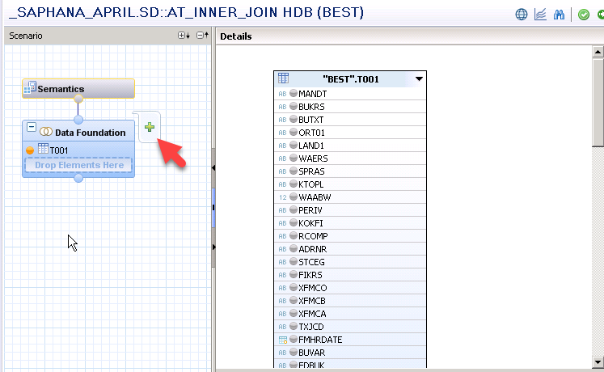

Select TVKO and click ok

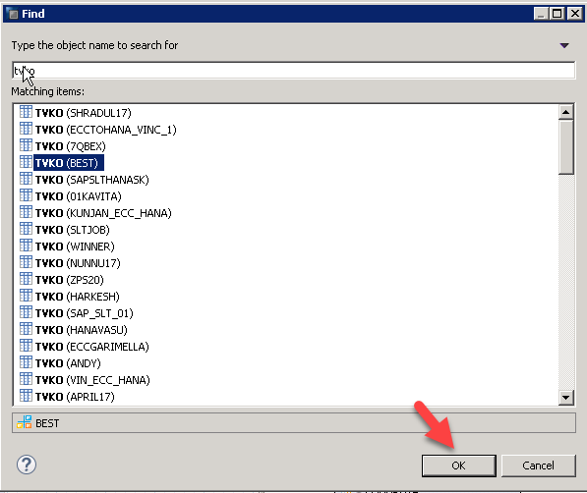

Again click on data foundation +icon to add TVKOT table

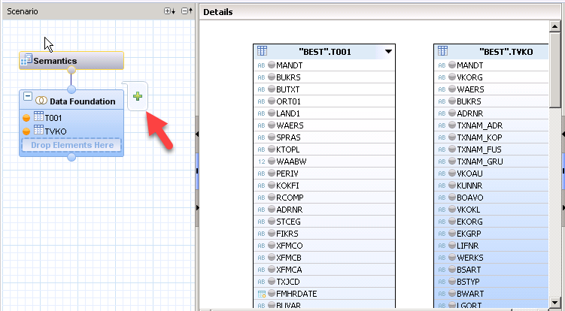

Select TVKOT table and click ok

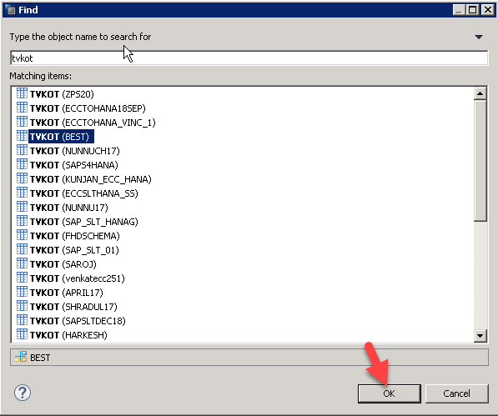

Again click on data foundation + icon to add TCURT table

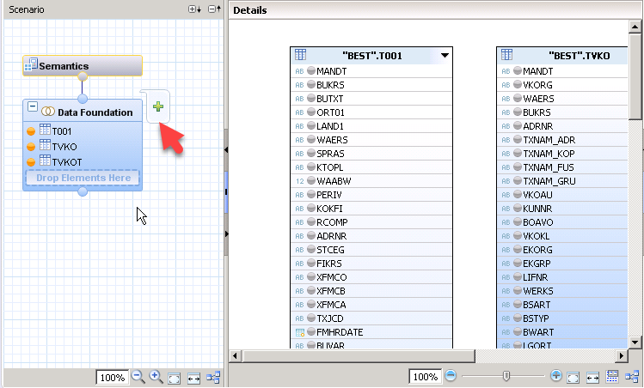

Select TCURT table and click ok

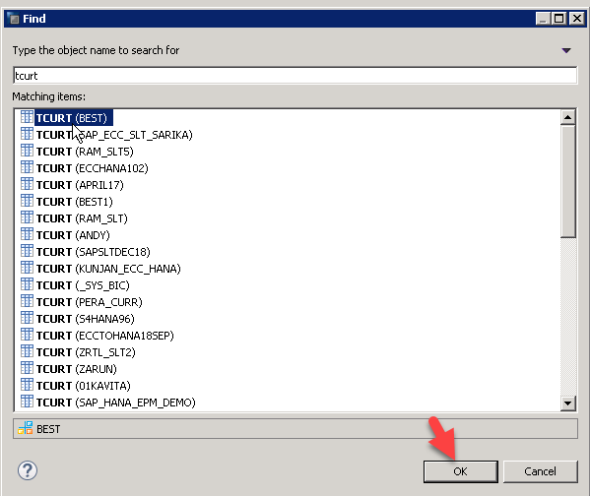

Define relationship between TVKO BUKRS to T001 BUKRS and provide join type as Inner

**Inner Join**:

* The inner join select the records that match in both the tables
* Inner join should be used if referential integrity is ensured.
* Inner Join is much faster that Outer Join thus is the preferred solution if possible from semantically perspective.
* Inner Joins can be used to join different master data tables to a joint dimension Analytical Views.
* Inner Joins can be used if referential integrity cannot be ensured

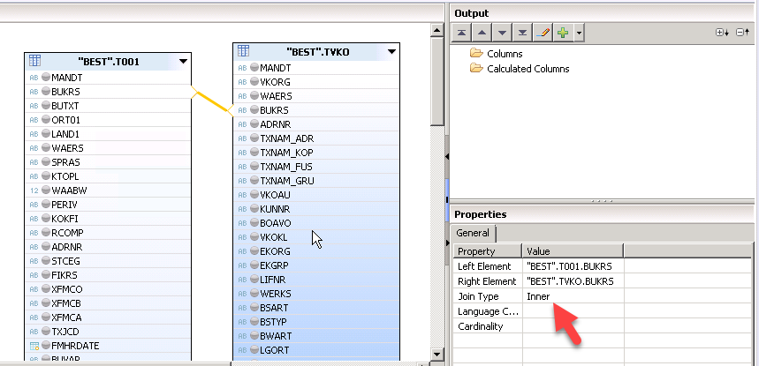

Define relationship between TVKO VKORG TO TVKOT VKORG and provide join type as Text join

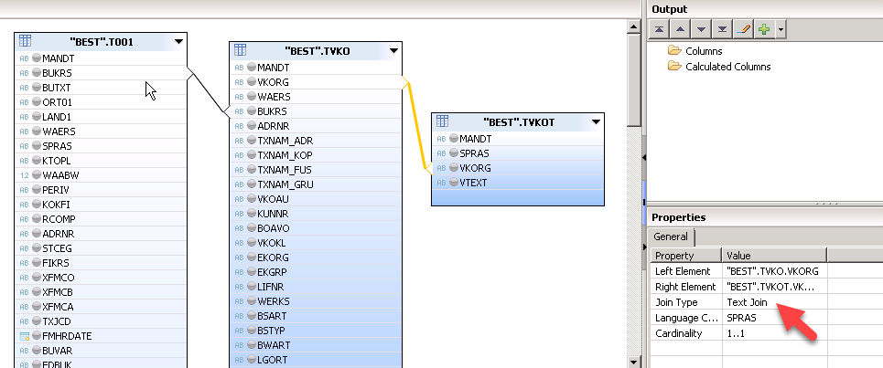

Define relationship between T001 WEARS TO TCURT WEARS and provide join type as Text join

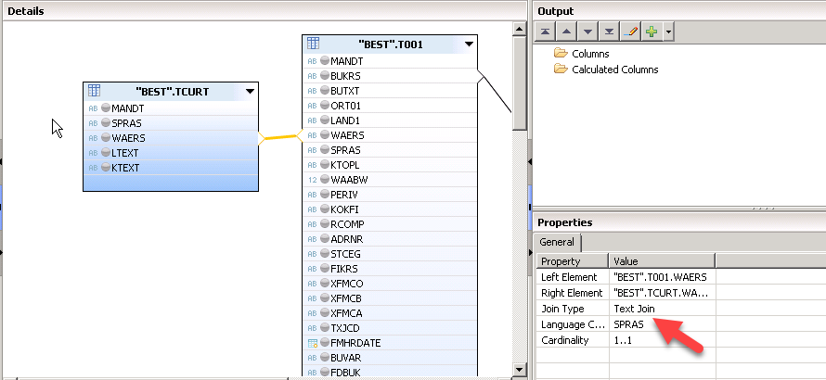

Select fields for output

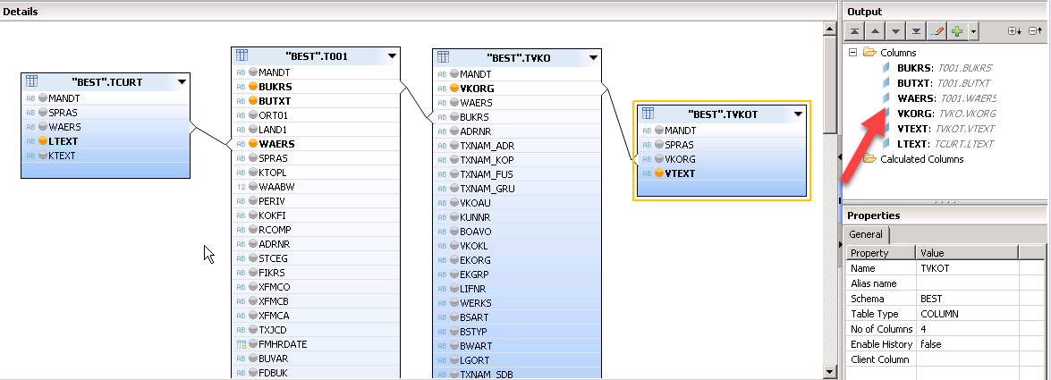

Select BUKRS as key attribute

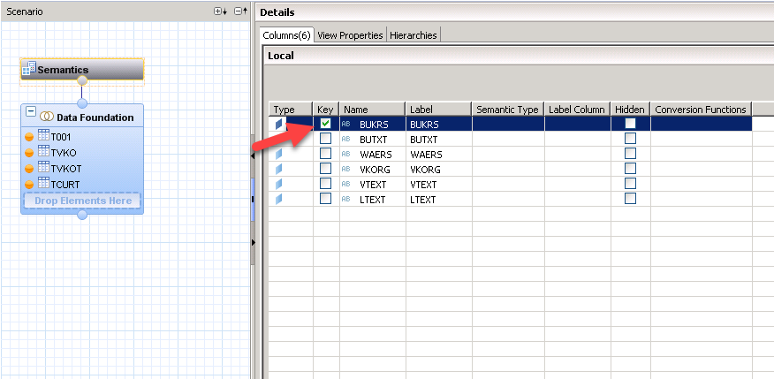

Select label columns

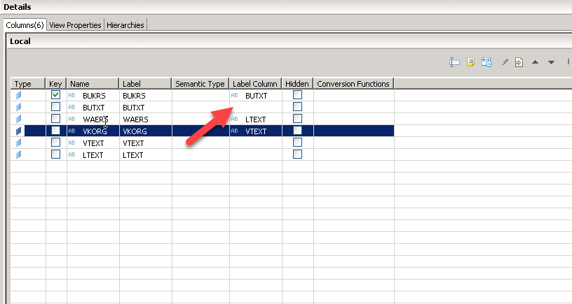

Click on save and validate<save and activate

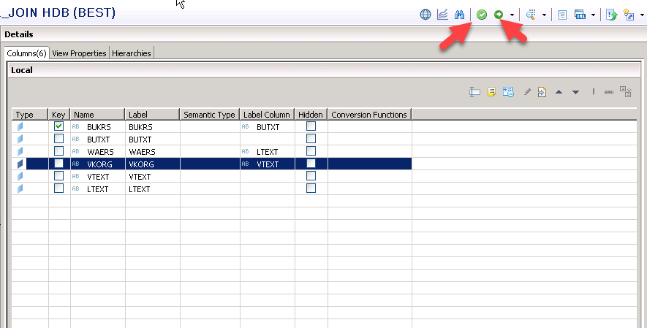

Assign objects for a change

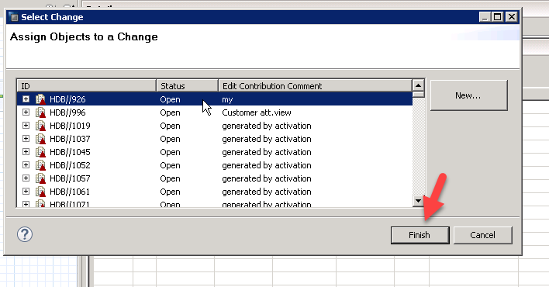

Click on data preview

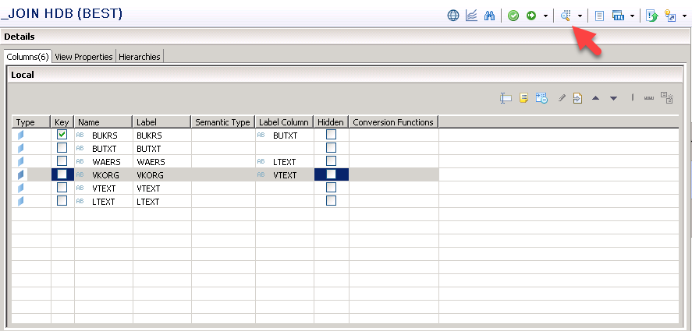

Click on raw data

